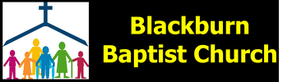
Welcome to Blackburn Baptist Church, on January 15th 2023 at 10:45, meeting at Bethesda Chapel.
Whilst some are able to meet in person, others we know are still at home. We hope and pray that you will find this outline of our service helpful, as we seek to worship God as a Church family, wherever we are.
Our service today is being led by Alec, and Trevor is playing the piano for us. The notices were shown on the screen. (There were a few blips today as the computer or screen decided not to co-operate and we had a few instances of a blank screen, but fortunately only for short periods during the hymns and songs, and we were able to remember the words!!)
Alec welcomed everyone, and read Psalm 2.
Why do the nations conspire and the peoples plot in vain?
The kings of the earth rise up and the rulers band together
against the Lord and against his anointed, saying,
“Let us break their chains and throw off their shackles.”
The One enthroned in heaven laughs; the Lord scoffs at them.
He rebukes them in his anger and terrifies them in his wrath, saying,
“I have installed my king on Zion, my holy mountain.”
I will proclaim the Lord’s decree: He said to me, “You are my son; today I have become your father. Ask me, and I will make the nations your inheritance,
the ends of the earth your possession. You will break them with a rod of iron; you will dash them to pieces like pottery. Therefore, you kings, be wise; be warned, you rulers of the earth. Serve the Lord with fear and celebrate his rule with trembling. Kiss his son, or he will be angry and your way will lead to your destruction,
for his wrath can flare up in a moment. Blessed are all who take refuge in him.
Alec then prayed:
“Loving Heavenly Father, we thank you that we can come before you together in this place today, that we have this freedom still in this country today to do that. We ask that you will lead us and guide us in this meeting, that you will comfort and help those who are alone today, not able to come to this meeting, not able to go to any meeting because meetings are not allowed, be with all who love you from the heart, all your children today. Build them up and strengthen them in their most holy faith, for we pray in the name of the Lord Jesus Christ and for his sake. Amen.”
He then explained that he had divided the service today into two parts; we will be sharing firstly in a time of praise and worship, (that is, a number of hymns and songs sung in a block) followed by the spoken word, including his message and our prayers of intercession. He then invited Trevor to play our Opening hymn, with all invited to stand or sit as they so wished:
O Jesus, I have promised to serve thee to the end;
be thou forever near me, my Master and my friend;
I shall not fear the battle if thou art by my side,
nor wander from the pathway if thou wilt be my guide.

O let me feel thee near me! The world is ever near:
I see the sights that dazzle, the tempting sounds I hear.
My foes are ever near me, around me and within;
but, Jesus, draw thou nearer, and shield my soul from sin.

O let me hear thee speaking in accents clear and still,
above the storms of passion, the murmurs of self-will.
O speak to reassure me, to hasten or control;
O speak, and make me listen, thou guardian of my soul.

O Jesus, thou hast promised to all who follow thee
that where thou art in glory there shall thy servant be.
And, Jesus, I have promised to serve thee to the end;
O give me grace to follow, my Master and my friend.

Authors: James William Elliott, John Ernest Bode CCLI Song # 1831356 Words and music Public Domain CCL No 5664 This was followed by a Worship song, shown on the screen:

You were the Word at the beginning, one with God the Lord Most High,
your hidden glory in creation now revealed in you our Christ.
What a beautiful name it is, what a beautiful name it is,
the name of Jesus Christ my King.
What a beautiful name it is, nothing compares to this,
what a beautiful name it is, the name of Jesus.

You didn't want heaven without us, so Jesus, you brought heaven down.
My sin was great, your love was greater, what could separate us now?
What a wonderful name it is, what a wonderful name it is,
the name of Jesus Christ my King.
What a wonderful name it is, nothing compares to this,
what a wonderful name it is, the name of Jesus.

Death could not hold you, the veil tore before you,
you silenced the boast of sin and grave.
The heavens are roaring the praise of your glory,
for you are raised to life again.
You have no rival, you have no equal, now and forever, God you reign.
Yours is the kingdom, yours is the glory,
yours is the name above all names.
What a powerful name it is, what a powerful name it is,
the name of Jesus Christ my King.
What a powerful name it is, nothing can stand against;
what a powerful name it is, the name of Jesus.
What a powerful name it is, the name of Jesus,
What a powerful name it is, the name of Jesus.

Authors: Ben Fielding, Brooke Ligertwood CCLI SONG # 7068424 Copyrights @ 2016 Hillsong Music Publishing Australia (Admin. by Hillsong Music Publishing UK) CCL No 5664
Trevor then played again as we sang:
Bless the Lord oh my soul, oh my soul, worship His Holy name;
sing like never before, oh my soul, I’ll worship Your Holy name. The sun comes up - it’s a new day dawning, it’s time to sing Your song again.
Whatever may pass and whatever lies before me,let me be singing when the evening comes. Bless the Lord oh my soul, oh my soul…. You’re rich in love and You’re slow to anger, Your name is great and Your heart is kind.
For all Your goodness I will keep on singing - ten thousand reasons for my heart to find. Bless the Lord oh my soul, oh my soul….. And on that day when my strength is failing, the end draws near and my time has come, still my soul will sing Your praise unending, ten thousand years and then forevermore. Bless the Lord oh my soul, oh my soul….
Written by Matt Redman and Jonas Myrin CCLI SONG #6016351 Copyrights @ 2011 Thankyou Music (Admin. by Integrity Music Ltd) Atlas Mountain Songs (Admin. by SHOUT! Music Publishing UK)No 5664 This was followed by another Worship song shown on the screen: Light of the world, You stepped down into darkness, opened my eyes, let me see beauty that made this heart adore you, hope of a life spent with you. Here I am to worship, here I am to bow down, here I am to say that you're my God. You're altogether lovely, altogether worthy, altogether wonderful to me. King of all days, so highly exalted, glorious in heaven above; humbly you came to the earth you created, all for love's sake became poor. Here I am to worship….. I'll never know how much it cost to see my sin upon that cross… I'll never know how much it cost to see my sin upon that cross… Here I am to worship….. Call upon the name of the Lord and be saved…… Authors: Tim Hughes, Chris Tomlin CCLI SONG # 3266032 Copyrights @2000 Thankyou Music (Admin. by Integrity Music Ltd)Copyright@2000 Kingsway Music CCL no 5664
And finally in this section of the service, Trevor once more played the piano as we sang:
Ascribe greatness to our God, the Rock,
his work is perfect and all His ways are just.
Ascribe greatness to our God, the Rock,
his work is perfect and all His ways are just.
A God of faithfulness and without injustice,
good and upright is He;
A God of faithfulness and without injustice,
good and upright is He.

Authors: Mary Kirkbride, Mary Lou Locke, Peter West, Copyright@1979 Peter West, admin by Integrity’s Hosanna Music/Kingsway’s Thankyou Music; CCL No 5664

Brenda then came to read: Bible Reading Isaiah 41: 1-10 - she had just about enough voice left!
“Be silent before me, you islands! Let the nations renew their strength!
Let them come forward and speak; let us meet together at the place of judgment.
“Who has stirred up one from the east, calling him in righteousness to his service?
He hands nations over to him and subdues kings before him.
He turns them to dust with his sword, to windblown chaff with his bow.
He pursues them and moves on unscathed, by a path his feet have not travelled before.
Who has done this and carried it through, calling forth the generations from the beginning?
I, the Lord—with the first of them and with the last—I am he.”
The islands have seen it and fear; the ends of the earth tremble.
They approach and come forward;
they help each other and say to their companions, “Be strong!”
The metalworker encourages the goldsmith,
and the one who smooths with the hammer spurs on the one who strikes the anvil.
One says of the welding, “It is good.” The other nails down the idol so it will not topple.
“But you, Israel, my servant, Jacob, whom I have chosen,
you descendants of Abraham my friend,
I took you from the ends of the earth, from its farthest corners I called you.
I said, ‘You are my servant’; I have chosen you and have not rejected you.
So do not fear, for I am with you; do not be dismayed, for I am your God.
I will strengthen you and help you; I will uphold you with my righteous right hand.

Alec shared his message - Do not fear - with some pictures shown pin the screen.
Did you enjoy looking at the pictures last week? Were they helpful to you? I think there`s an awful lot in a picture isn`t there? I`m sure they are helpful when we choose the right ones. Let`s look today at this one first. So I won`t say like I did last week with the woman of Samaria, “Who do you see in this picture?” but can do you probably see in this first picture today?
Answers from congregation: stepping stones, a staircase.
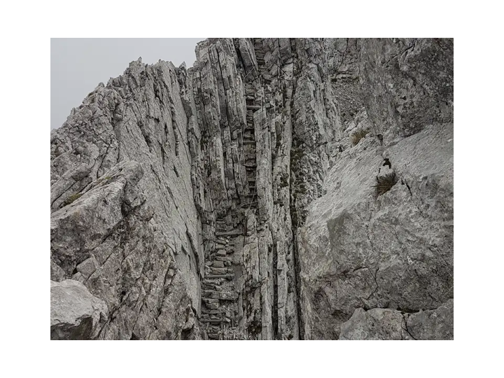
I want us to think maybe during the course of this message and maybe during the coming week, what is it that this picture shows about the way ahead for us and what does it show that is clearly not the way ahead for us? What are the challenges? What are the difficulties? What does this picture show?
Member of congregation: “It is hard.”
Yes it is hard, especially when you get there and look at it in front of you.
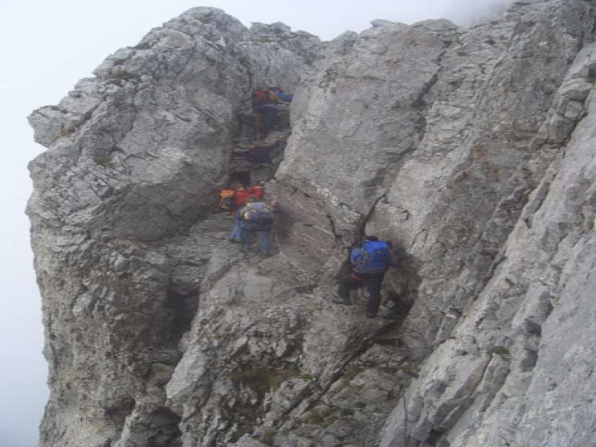
The next picture shows a more general view of it. It`s not my suggestion that we make it an obligation for church members to go there and climb it. But there are differences in this picture to the previous picture. What are the main differences apart from the fact that the picture gives a wider perspective?
Congregation: “People.”
Yes there are people in it; and these people don`t look as though they are going for a bathe on some sort of Mediterranean beach. They look in my opinion a little bit over-prepared; at least they are carrying an awful lot of weight on their backs. But they are not on their own. They are not getting in each other`s way. There are all kinds of things.
In what ways is our way ahead related to some of the characteristics you can see in these pictures? Let`s have these pictures in our minds in the coming week and maybe I think the Lord will help us to see and understand things from these pictures.
Last week we shared together here in a moving service of covenant renewal and this week we began with the words of the hymn
”O Jesus, I have promised to serve you to the end; be forever near me, my Master and my friend; I shall not fear the battle if you are by my side, nor wander from the pathway for you are now my guide.”
We have recommitted our individual and corporate lives to the Lord Jesus Christ on this basis. What a wonderful step to have taken together.
So what kind of modus are we in now? I think we are agreed we are in a “wait and see” modus. That means concretely we have essentially a blank piece of paper in our hands as we wait on the Lord to lead us. We are a praying fellowship and a fellowship of the Word. We have given Him all authority to lead us as we live out and share the Gospel of Christ. The leadership team has recommitted itself to spending time together in prayer and in waiting on the Lord; and central to this is a knowledge and understanding of what He has revealed to us in and through His Word.
Today we are looking together at Isaiah 41:1-10 which Brenda so kindly read for us.
Last week at the close of our formal covenant renewal service liturgy we joined together in singing the Creed whilst watching a film of life in the city of Kyiv, the capital of the Ukraine. I think in all of our hearts we were moved as we did that. And I think we ask ourselves maybe daily why does God allow such horrible things to happen like those we may witness on our TV screens, scenes of hate and seemingly endless destruction; apparently unbelievable suffering. Is God really in control of what is going in in His world and in the lives of those He made? Is He in control of my life?
The simple answer is of course yes He is.; because He is God; because He is Lord of all.
In Isaiah 41:1 God says: “Be silent before me, you islands! Let the nations renew their strength! Let them come forward and speak; let us meet together at the place of judgment.”
God sends out an invitation, He calls out to the nations. He sets up a hub, a centre, a meeting place like a courtroom because He longs for the entire world, not just the Jewish world, to gain access to and enjoyment of His love, His goodness and His blessings. He comes to Galligreaves and meets us on the street, introduces Himself and says who He is and what He is about.
He says: “Who has stirred up one from the east, calling him in righteousness to his service?” And the people of Galligreaves say like what is He saying? What does He mean? What has that got to do with us in 2023 in this apparently to some people God-forsaken place?
So God explains who He is and what He is doing.
Now to be honest with you this verse 2a of Isaiah 41 is quite difficult to understand. Who is it that has come from the east? Many say this is a reference to the Persian king Cyrus who oversaw the defeat of Babylonia which led to the Jewish exiles being freed. Others go a little further back and say this is referring to Abraham, who was a righteous man, believed in Christ for righteousness, had the righteousness of faith when circumcised and was himself just and righteous.
Basically in these opening verses of Isaiah 41 we see this person whoever it was being used by God to show us and all the peoples of the world who He is. God asks the question ““Who was it that brought the conqueror from the east and makes him triumphant wherever he goes? Who gives him victory over kings and nations? His sword strikes them down as if they were dust. His arrows scatter them like straw before the wind.”
And God gives the answer to us all, even those of us in Blackburn. He says as we read in verse 4:
“Who did this? Who made it happen? Who always gets things started? I did. God. I’m first on the scene. I’m also the last to leave.” “Who has done this and carried it through? I the Lord-I am He.”
The great I am, the Lord, is in control of everything that has gone on, is going on and will go on in the world.
We see that very rarely in our mass media. Just imagine the TV newsreaders beginning, “Let`s see what God has done and is doing in our world today.”
Our God is the God of world history-after all, He made it.
So how do nations, how does mankind, how do people respond to the reality of God?
They separate themselves from the living God and they hold together, work together and make and serve idols together; they do everything together and they live in fear; fear of themselves, fear of the future, fear never-ending. It is the people God made, who turn away from Him.
Having been called collectively to come to God these nations have run collectively to the making of idols. They use the human skills that they have been given and human judgement but they turn away from the voice of God. They know they don’t have the answers. They know there is something more than they are experiencing. “The islands have seen it and fear; the ends of the earth tremble.”
The response of fear is to make idols as a sort of defence mechanism against the difficulties of life.
God says “Be silent! Listen to me.” But the peoples of the world are not silent and they do not listen. They are very, very busy building blockades in their hearts and minds against the truth of the one and only living God. They are proud and stubborn in their hearts.
What are modern day idols? Modern day idolatry is alive and well. Anything that you love, treasure, prioritise, identify with, or look to fulfil your needs with outside of God, can be acting as an idol in your heart and life.
We might do well to ask ourselves questions like these. I find these to be honest very difficult and challenging because I always really want to say no each time but I honestly can`t.
Do I prioritise anything or anyone before God? Does anything bring me more pleasure than the things of God? Do I place my identity in anything over my status as a child of God? Do I look to anything or anyone to meet my needs instead of God? Do I seek fulfilment or satisfaction from anything outside of God? Do I seek comfort outside of God? Do I love or treasure anything or anyone more than God?
But you see probably I am not the only person here present this morning or watching the recording who finds this a really challenging exercise.
We do not need to hammer another nail into the structure of our lives to stop the idol from breaking up, from falling, from toppling. We just need to look together to the Lord.
We have given God enough reasons to reject us. How does He respond?
In verses 8-9 we read: “But you, Israel, are My servant, Jacob whom I have chosen, the seed of Abraham, My friend. You whom I have taken from the ends of the earth, and called from its remotest parts, and said to you, “You are My servant. I have chosen you and have not rejected you.””
God says He has brought us, He has called us, He has chosen us and not rejected us. SO DO NOT FEAR.
Are we fearful this morning? Are we dismayed? That means really are we darting glances this way and that not knowing where to look for safety? Are we afraid? Are we anxious? Are we frustrated not knowing what to do? Are we discouraged?
God says to you and to me right now and always, I am the Lord, I am He. So do not fear. I will strengthen you; I will help you; I will uphold you with my righteous right hand.
The opposite of fear is faith. Have a read through of the letter to the Hebrews chapter 11 and be repeatedly and amazingly encouraged. If God put a baby in Sarah`s arms, parted the Red Sea for Moses, made the sun stand still for Joshua, closed the lion`s mouth for Daniel, raised Lazarus from the dead and opened the closed prison doors for Peter He can certainly take care of you. You do not need to be afraid and neither do I.
“The LORD is my light and my salvation— whom shall I fear? The LORD is the stronghold of my life— of whom shall I be afraid?” (Psalm 27:1)
There is a massive contrast between the people of God and the surrounding nations. Isaiah 41:10 is exclusive in its application. To whom do these promises “Do not fear for I am with you”, “Do not be dismayed for I am your God”, “I will strengthen you and help you and uphold you” with my righteous right hand” apply? In 1 Peter 1: 3 we read that these promises apply to those who have been given new birth into a living hope through the resurrection of Jesus Christ from the dead; in 1 Peter 1:8 we read that though we have not seen him we love him; and even though you do not see him now you believe in Him and are filled with an inexpressible and glorious joy; in 1 Peter 1:23 we read that we have been born again through the living and enduring Word of God and in 1 Peter 2:3 we read that we have now tasted that the Lord is good.
In 1 Peter 2: 9-10 the characteristics of believers, the people of God are set out like this. It is like a heavenly banquet!
“But you are a chosen people, a royal priesthood, a holy nation, God’s special possession, that you may declare the praises of him who called you out of darkness into his wonderful light. Once you were not a people, but now you are the people of God; once you had not received mercy, but now you have received mercy.”If we grasp just a little bit of all that involves, if we understand only a small fraction of what that means, I think and feel that we will be excited almost without limits for then we then know that we do not need to fear. Hallelujah.
Do you know many times the phrase “DO NOT FEAR” is found in the Bible? It is found 365 times.
So God says to you every day: * Do not gaze about in anxiety * Don`t you bother yourself about these and about those things * Don`t you take on board burdens that I never expected you to bear
There is no area of our lives over which we need to lose any part of one night`s sleep for God says, “I will fulfil my purposes for you so do not fear.”
My original title for this message was:
“TRANSFORMATION IN PROGRESS: DO NOT FEAR”
Maybe He is transforming you and not transforming your circumstances? Maybe He is transforming you through your circumstances? Maybe He is transforming you through not transforming your circumstances?
And you say “But I don`t want that Lord.” “Please change this or that” and He says “My grace is sufficient for you.” “Look at me my child.”
We may think or feel that we have reasons to fear. We may feel God is far away but He isn`t. He came down to earth and gave His life that we might be forgiven and He lives in all those who have received Him and become children of God; we are being changed into His likeness.
“Listen, I tell you a mystery: We will not all sleep, but we will all be changed— in a flash, in the twinkling of an eye, at the last trumpet. For the trumpet will sound, the dead will be raised imperishable, and we will be changed.” Amen.
Our Prayers of Intercession were led by Jane.
‘Firstly, to share some thoughts from my Bible reading notes (SU Daily Bread): How does God feel about our prayers? Do we feel we need to get his attention by our persistence and wear him down until he gives in and answers us? No, he is loving, he listens and above all, he is powerful and eager to act. ‘Prayer is part of a bigger scheme. When we pray, we are not letting God know about something that has skipped his attention. Nor are we letting him in on news he hasn’t heard yet. Prayer doesn’t change God. Prayer changes us! It is God’s way of letting us into his mind and heart so that we might be changed into his likeness and join in his agenda for his world.’
So, let’s pray to the God who says: ‘.. do not fear, for I am with you... I will strengthen ... help and uphold you ...‘ (Isaiah 41:10)
Heavenly Father, we come before you humbly today in the knowledge that we are powerless to change even our own lives, let alone the world we live in, but trusting in your everlasting love for each of us and your desire to mould us into the image of your Son, Jesus, who died to save us from our sins.
We thank you, Lord, for this new year and the hope that it brings. Yet we look at the problems of the world and the difficulties in our own country at this time and we see no way that they can be resolved except by your intervention in the hearts and minds of those who have power to change things.
And so we pray for world leaders who will seek peace rather than wage war, who will work with others to combat the environmental challenges and changes that are causing death and destruction, and who will put as their priority the needs and well-being of all the citizens under their care. Lord, only you can bring about such a transformation. We pray too for your church throughout the world, that your people would be emboldened and strengthened to work for you and spread the knowledge of your saving grace in Jesus.
We pray for our own country and our government. Lord, you know how so many people are struggling to make ends meet, how the NHS is so over-stretched with lack of staff and increasing demands and how daily life is disrupted for so many by on-going strikes. There also seems to be increasing violence on our streets and we pray especially for the six girls and women caught up in the shooting outside a church in London yesterday. We pray, Father, that you would guide all those concerned into finding solutions to our problems. Above all, we pray that many people would turn back to you in repentance and seek your ways in their lives when faced with all the trials of life. Help us to be bold enough to speak about you to our families, neighbours and friends.
Father, we bring before you now the many members of our church family. We pray for those suffering bereavement, especially Jean Guest and her family after the sudden death of her husband, George, this week. We pray for those who are at this time struggling with health issues and the frailty of old age. We think of those in hospital and those unable to get out and about, frustrated that they cannot do the things they used to do. We pray for those suffering from winter viruses they can’t seem to shake off; for those who find it hard to remember, and others who are beset by memories they want to leave behind; for those who are waiting for appointments and those who have decisions to make about their treatment. Thank you for the people who care for them all, nurses and doctors and family members; please continue to give them your daily strength and compassion. We ask that you would bring your healing touch to all for their ailments, and inwardly, so that they may experience your peace that passes all understanding and so bring glory to your Name. We ask all our prayers through the precious name of Jesus, Amen.’

Our Closing (Offering) hymn was again played by Trevor:
A mighty fortress is our God, a bulwark never changing, our helper he, amid the flood of moral ills prevailing. For still our ancient foe does seek to work us woe;
his craft and power are great, and armed with cruel hate,
on earth is not his equal.

Did we in our own strength confide, our striving would be losing,
were not the right Man on our side, the Man of God's own choosing.
You ask who that may be? Christ Jesus, it is he;
Lord Sabaoth his name, from age to age the same;
and he must win the battle.

And though this world, with devils filled, should threaten to undo us,
we will not fear, for God has willed his truth to triumph through us.
The prince of darkness grim, we tremble not for him;
his rage we can endure, for lo! his doom is sure;
one little word shall fell him.

That Word above all earthly powers no thanks to them abideth;
the Spirit and the gifts are ours through him who with us sideth.
Let goods and kindred go, this mortal life also;
the body they may kill: God's truth abideth still;
his kingdom is forever!

Authors; Frederick Henry Hedge, Martin Luther CCLI SONG # 3578816 words and music:Public Domain CCL No 5664
Alec prayed as he received the Offering: Loving Heavenly Father, we thank you for all the good gifts you give to us and we ask that you will bless the gifts that we have given as a small token of our thanks. Amen.
We brought our time or worship to a close as we were invited to join together in saying: Now to him who is able to keep you from stumbling and to make you stand in the presence of his glory blameless with great joy, to the only God our Saviour, through Jesus Christ our Lord, be glory, majesty, dominion and authority, before all time, now and forever, and the grace of our lord Jesus Christ, the love of God and the fellowship of the Holy Spirit, be with us evermore. Amen.

